Praying with Purpose: ABC of prayer for MU@home

A prayer template for members of MU@home, whether permanently housebound or unable though circumstances to join with prayer groups

Each group will need to ensure that the MU@home members are kept up to date with prayer requests, progress and answers to prayer. Ideally, they should also be able to share their own insights from God with the group and/or the project

A Begin by offering your praise and thanks for answered prayer so far. Remind

yourself of the power of prayer and God’s willingness to answer by reflecting on

appropriate Bible verses

Loving Lord, thank you for the privilege of being involved in the work of building the Kingdom of God on earth through my prayers for (mention the specific project/initiative etc.)
I praise you with thankful heart for your answers to prayers thus far, in particular (mention specific answers) Truly you are an awesome God!

Thank you for your presence with me as I bring my requests
and petitions.
Thank you for the help of the Holy Spirit in putting needs into words, and in pleading their case before you.
I commit my time to you, for the growth of your Kingdom
and the glory of Christ. Amen

B Now move into praying for specific aspects of the initiative:

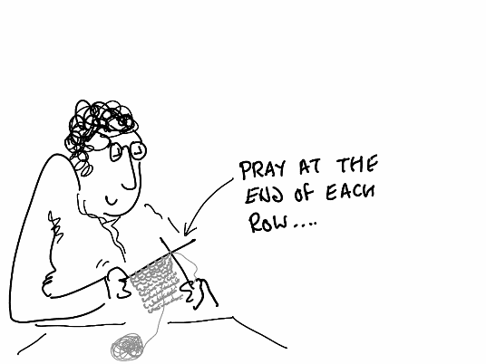
- As well as bringing before God the prayer points you have been given you may like to choose appropriate passage of scripture, reflect on it for a few minutes then use the thoughts God highlights to you to pray for the initiative.

- If you enjoy craft activities you could also engage in them as another way to pray – especially if the project includes craft in some way e.g. knitting – pause after every row to pray; focus on those who will benefit from the knitted item and use your thoughts as a basis for prayer

Write down any particular themes that emerge as you prayer and pass them on to those involved in the project

C Finish by using a Biblical blessing to ask God to bless the work for which you have

been praying

